**PRACTICAL NO:1**

**Introduction to Excel**

1) Create a dataset

2) Sort Data: Step i) Select the entire table

ii) Go to Data tab → Sort → Sort by Department (A–Z) → ok

3) Apply Filter: Step i) Select the header row.

ii) Go to Data tab → Filter

iii) Click on the dropdown in “Department” and select only Science.

4) Write Formulas: i) Total Sum→=sum(Number1,Number2,…..) i.e select range

ii) Average→=Average(Number1,Number2,…..) i.e select range

iii)Result → =if(logical_test,”pass”,”fail”) or =if(logical_test,”true”,”false”)

5) Remove Duplicates: Step i) Copy Department column → Data tab → Remove Duplicates

→ select Department →OK

**Output:**



|  |  |  |  |  |  |
| --- | --- | --- | --- | --- | --- |
| Roll No | Name | Department | Marathi | Maths | English |
| 1 | Alankar | science | 78 | 35 | 58 |
| 2 | Daksh | commerce | 47 | 67 | 35 |
| 3 | Machya | science | 78 | 58 | 46 |
| 4 | Atish | Arts | 38 | 54 | 56 |
| 5 | Jeevan | commerce | 90 | 79 | 80 |

|  |  |  |  |  |  |
| --- | --- | --- | --- | --- | --- |
| Roll No | Name | Department | Marathi | Maths | English |
| 4 | Atish | Arts | 38 | 54 | 56 |
| 2 | Daksh | commerce | 47 | 67 | 35 |
| 5 | Jeevan | commerce | 90 | 79 | 80 |
| 1 | Alankar | science | 78 | 35 | 58 |
| 3 | Machya | science | 78 | 58 | 46 |

|  |  |  |  |  |  |
| --- | --- | --- | --- | --- | --- |
| Roll No | Name | Department | Marathi | Maths | English |
| 1 | Alankar | science | 78 | 35 | 58 |
| 3 | Machya | science | 78 | 58 | 46 |

|  |  |  |  |  |  |  |  |  |
| --- | --- | --- | --- | --- | --- | --- | --- | --- |
| Roll No | Name | Department | Marathi | Maths | English | Total marks | Average marks | Result |
| 1 | Alankar | science | 48 | 20 | 58 | 126 | 42 | fail |
| 2 | Daksh | commerce | 47 | 67 | 35 | 149 | 49.66666667 | fail |
| 3 | Machya | science | 78 | 58 | 46 | 182 | 60.66666667 | pass |
| 4 | Atish | Arts | 38 | 54 | 56 | 148 | 49.33333333 | fail |
| 5 | Jeevan | commerce | 90 | 79 | 80 | 249 | 83 | pass |

|  |  |  |  |  |  |
| --- | --- | --- | --- | --- | --- |
| Roll No | Name | Department | Marathi | Maths | English |
| 1 | Alankar | science | 48 | 20 | 58 |
| 2 | Daksh | commerce | 47 | 67 | 35 |
| 3 | Machya | science | 78 | 58 | 46 |
| 4 | Atish | Arts | 38 | 54 | 56 |
| 5 | Jeevan | commerce | 90 | 79 | 80 |

**PRACTICAL NO:2**

Data Entry and Manipulation

1. Create a dataset
2. Text-to-Columns: Step: i) Select the entire table ii)Go to Data tab → Text-to-Columns → Delimited iii)→Next →Comma → Finish.
3. Transpose Data: Step : i) Copy the table → Go to a new sheet → Right-click → Paste Special → Transpose.
4. Pivot Table: Step : i) Go to the Insert tab on the Ribbon. → Click Pivot →Table In the dialog box: selecte the data range In the dialog box: selecte the data range Choose whether you want the Pivot Table in (New Worksheet or the Existing Worksheet) → Click OK. → (We want to summarize total sales by Department )

Using Following Table

|  |  |  |
| --- | --- | --- |
| Name | Department | Sales |
| John | A | 200 |
| Priya | B | 300 |
| Ravi | A | 150 |
| Meera | B | 250 |
| Anil | A | 100 |
| Neha | B | 350 |

Output:-

1.

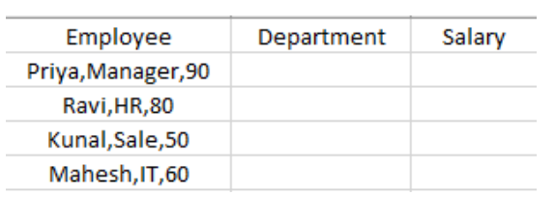

2.

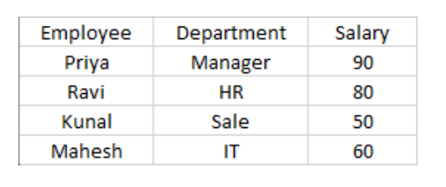

3.

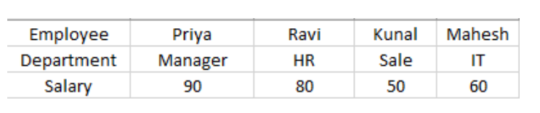

4.

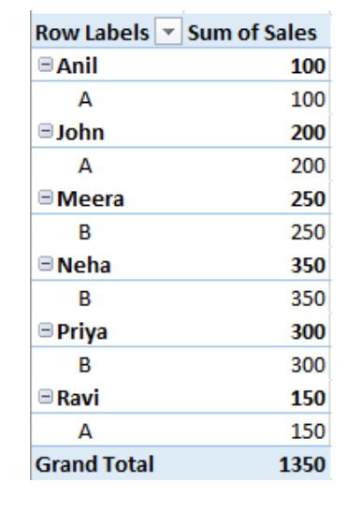

**PRACTICAL NO: 03**

We will create a simple dataset of student names and their marks in a subject. We want **1**

**1)MARKS MUST BE BETWEEN 0 AND 100:**

**Step:** i) select the marks column → GO to the Data tab → Data validation → Data Validation….

ii) In the dialog box → setting → Under Allow, Select Whole Number (or Decimal if you want to allow decimals) →Under Data, Select Between. →Enter minimum=0, MAXIMUM=100.

iii) Click OK.

**2) GRADE CAN ONLY BE CHOOSEN FROM A FIXED LIST:** A,B,C,D,F:

**Step:** i) Select the grade column → GO to the Data base → Data Validation → Data Validation…..

ii)In the dialog box → setting →Under allow, Select List. In the source box, type:

A, B, C, D, E, F

iii) Click OK.

**3) DATE OF BIRTH ONLY BE CHOOSEN FROM A FIXED DATA:**

**Step:** i) Select Date of Birth The Column → Go to the Data Tab → Data Validation→ Data Validation…..

ii) In the dialog box → Setting → Under Allow, select Data. → Under Data, select between→ start Date= 01\ 01\ 2006, End date=01\01\2008.

iii) Click OK

**Output:**

**1)**

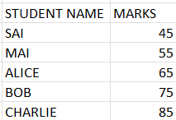

**2)**

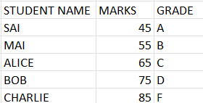

**3)**

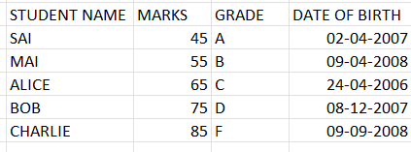

**PRACTICAL NO: 04**

**Aim: Diagram and Graph**

**1.EXCEL PROGRAM TO PLOT BAR CHART**

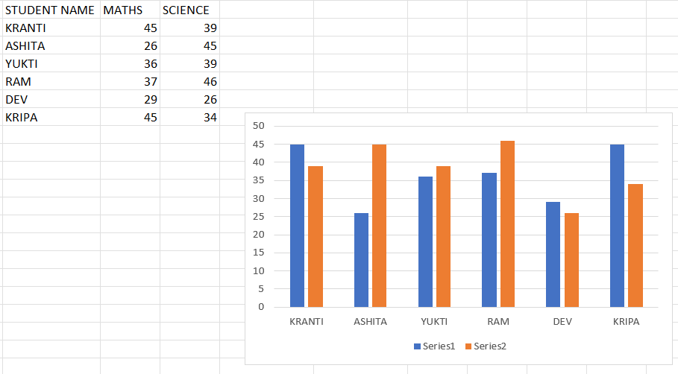

**2.EXCEL PROGRAM TO PLOT HISTOGRAM**

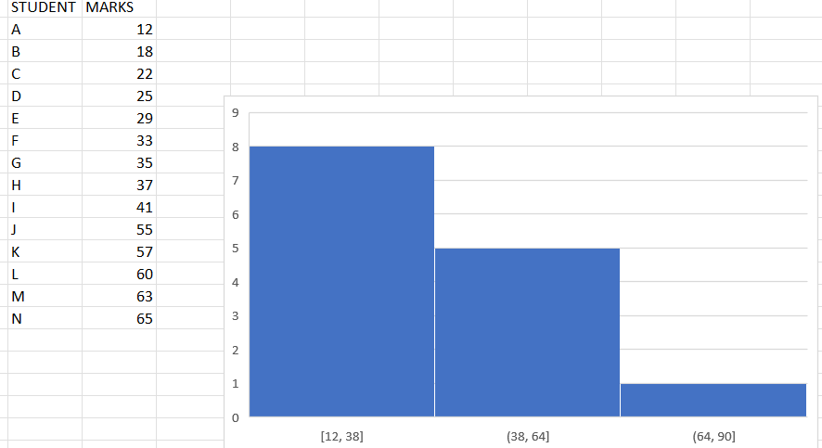

**3. Excel Program to plot pie Chart Using the data of Bar chart –** Add a Total Column to your table in excel < Use the Name and Column and the total Column to Make a pie chart

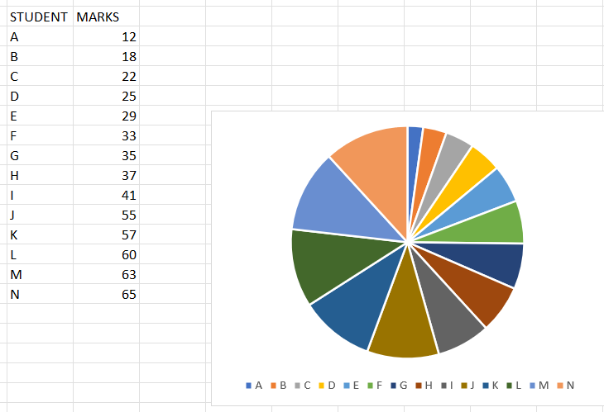

**4. Boxplot**

12,45,65,85,45,47,23,26,24,12,11,54,56,47,36,45,47

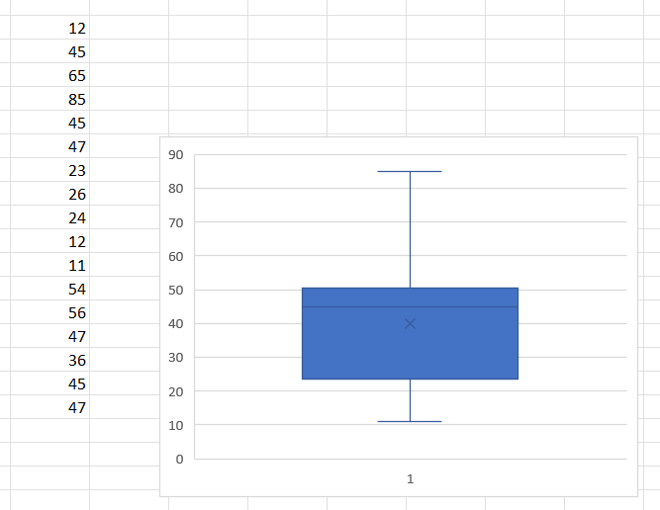

**PRACTICAL NO: 05**

**Aim: Measure of central tendency**

**1.Calculate mean, median and mode for the following data**

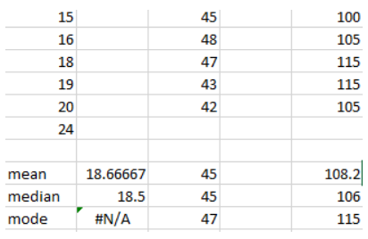

**2.Find mean**

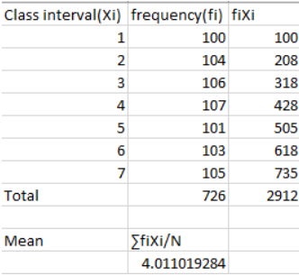

**3.Find mean or median**

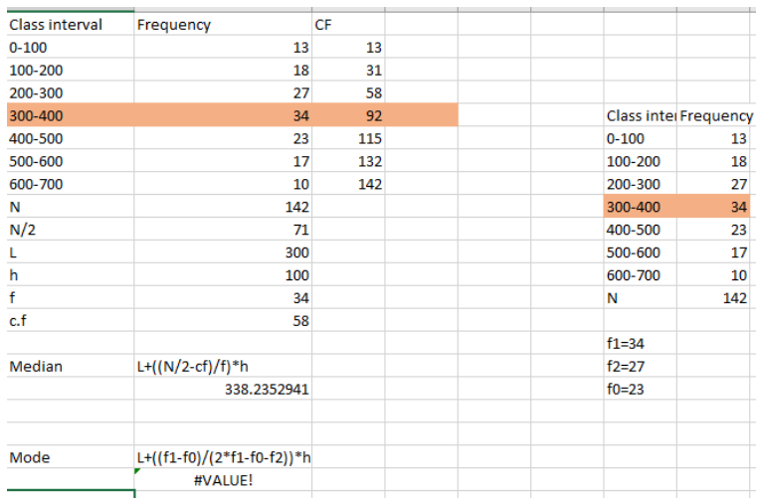

**PRACTICAL NO: 06**

**Calculate Range, Interquartile range, variance, Standard Deviation, Skewness and Kurtosis**

**Output:**

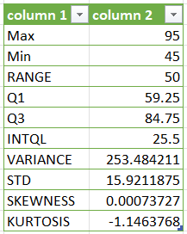

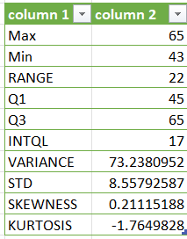

**PRACTICAL NO: 07**

**Aim: Correlation**

**Find Correlation**

**Output:**

**1)**

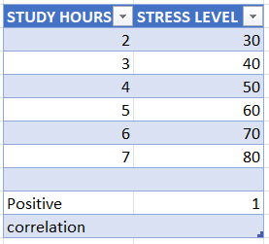

**2)**

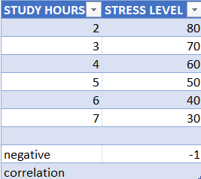

**3)**

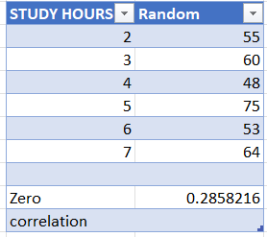

**PRACTICAL NO: 08**

**Aim: Regression**

**Output:**

**1)**

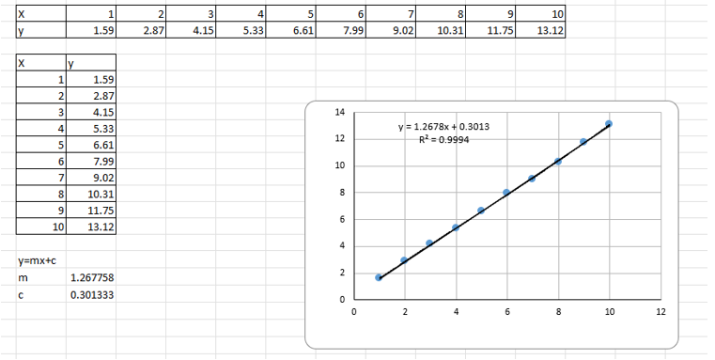

**2)**

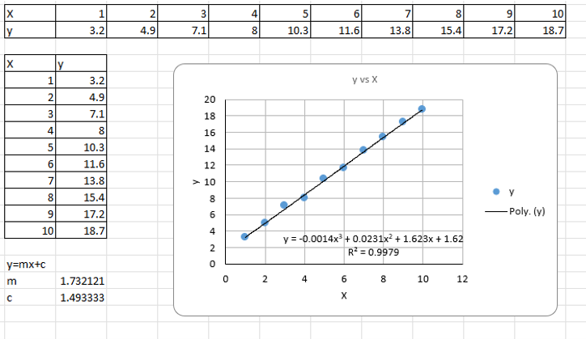

**PRACTICAL NO: 09**

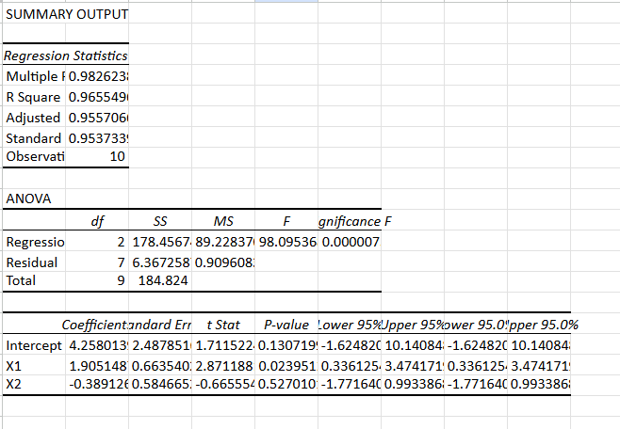

**PRACTICAL NO: 10**

**Aim:** **Design a survey form, collect primary data and analyse**

**Output:**

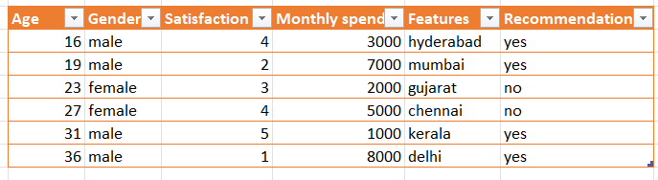



|  |  |
| --- | --- |
| **Column 1** | **Column 2** |
| mean | 25.3333333 |
| median | 3.5 |
| max | 8000 |
|  |  |

